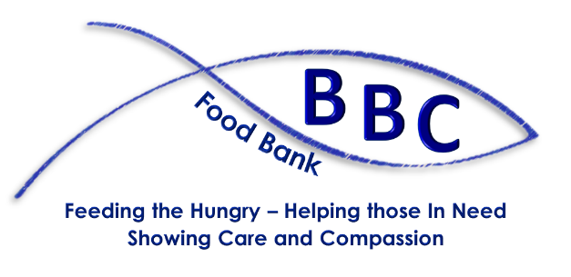
Bentley Baptist Community Food Bank
Referral Form
Please complete IN FULL and e-mail to
foodbank@bbcdoncaster.co.uk

Client’s Full Name

Client’s Address
(inc Post Code)

Client’s Contact Number

Clients Date of Birth

Household Size (Please complete with ages) ☐ Single ☐ Married ☐ living with partner
Ages of Adults: |  |  |  |  |  | Total Number:
Ages of Children: |  |  |  |  |  | Total Number:

Reason for Referral

(eg benefit delay/debt/etc)

Special Dietary Requirements
How long will support be required? (Please refer to “Support Period” overleaf)
☐ One-off ☐ 2 Weeks ☐ 3 Weeks ☐ 4 Weeks ☐ 5 Weeks ☐ 6 Weeks

Referring Agency:
☐ Doncaster Community Hub ☐ Key Worker/Social Worker **

☐ Doctor’s Surgery ** ☐ School ** ☐ Christian Church **

** Name of Organisation

Referrer’s Full Name

Please provide a publicly-available phone number

Date of Referral PTO for GDPR

Support Period: We are happy to agree to a referral lasting up to six weeks if you believe this is required. We will call you when the last parcel is being delivered to see if things have changed. However, we are relying on grants and donated food, so please don't just tick 6 weeks. And if things turn around in the meantime, do let us know, so that we can redirect unrequired support elsewhere. Thank you.

GDPR PRIVACY NOTICE

We are committed to ensuring that your privacy is protected and we strictly adhere to the provisions of all relevant Data Protection Legislation, including GDPR, ensuring all personal data is handled in line with the principles outlined in the Regulation.

Data from referring agencies will only be used for the purposes of processing or querying a referral. Data will be kept securely for a reasonable length of time to ensure transparency of the Food Bank operation.

Data concerning the Client will be kept and used to monitor frequency of access to the Food Bank. If a referral is made for someone living outside the Bentley area and there is another Food Bank that the Client may be able to access, we reserve the right to contact that Food Bank and enquire if an individual has accessed their provision.

Data will be kept for a reasonable period to enable the monitoring of referrals and access to the Food Bank. Anonymised data may be used for the purposes of reporting Food Bank usage and for future grant applications.

FOOD BANK USE ONLY

Date referral received Received by

Support First Final

Period Date Date

foodbank@bbcdoncaster.co.uk 07574 907597 BBCFoodbank
bbcdoncaster.co.uk/community

Bentley Baptist Community Food Bank
c/o Bentley Baptist Church, Askern Road, Bentley DN5 0EW
Bentley Baptist Church is a Charitable Incorporated Organisation
Registered in England and Wales Nº 1190319

